SALES OVERVIEW:
# 1. What are the top 10 products by total sales revenue?
#GROUP PRODUCTS BY REVENUE DESC LIMIT 10

SELECT PRODUCT_ID, SUM(SALES) AS SALES_REVENUE FROM ORDERS
GROUP BY PRODUCT_ID
order by SALES_REVENUE DESC
LIMIT 10;
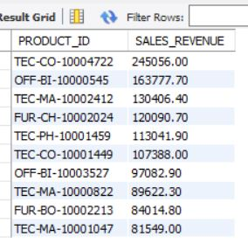

# 2. Which products have the highest average order value?
# GROUP BY PRODUCT ID, AVG (SALES)
SELECT PRODUCT_ID, avg(SALES) AS AVG_ORDER FROM ORDERS
GROUP BY PRODUCT_ID
order by AVG_ORDER DESC
LIMIT 10;
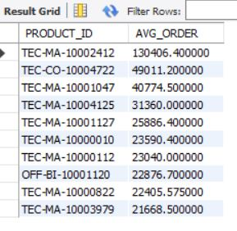
#3. What is the overall total revenue per month?
# EXTRACT MONTH FROM ORDER DATE, gp by month by sales

SELECT monthname(ORDER_DATE2) as month_, format(sum(sales),2) as total_sales FROM ORDERS
group by month(ORDER_DATE2) , monthname(ORDER_DATE2)
order by month(ORDER_DATE2);

# 4. How does revenue change month-over-month? // create a chart also
# use lag function for month over month

WITH monthly_revenue AS (
SELECT
MONTH(order_date2) AS month_num,
MONTHNAME(order_date2) AS month_name,
SUM(sales) AS revenue
FROM orders
GROUP BY MONTH(order_date2), MONTHNAME(order_date2)
)
SELECT
month_name,
FORMAT(revenue, 2) AS revenue,
FORMAT(revenue - LAG(revenue, 1) OVER (ORDER BY month_num), 2) AS mom_change,
FORMAT(((revenue - LAG(revenue, 1) OVER (ORDER BY month_num))
/ LAG(revenue, 1) OVER (ORDER BY month_num)) * 100, 2) AS mom_change_percent
FROM monthly_revenue
ORDER BY month_num;

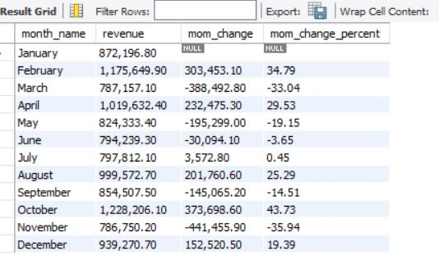
#5. Which day of the week has the highest average sales? //need in desc order

SELECT dayofweek(order_date2) AS DAY_NUM, dayname(order_date2) AS DAYS, format(avg(SALES),2) AS AVG_SALES FROM ORDERS
GROUP BY dayofweek(order_date2), dayname(order_date2)
ORDER BY AVG_SALES
lIMIT 1;

#6. What are the top 5 best-selling product categories (if category info exists)?
# GROUP CATEGORY BY SALES, DESC, LIMIT 5

SELECT CATEGORY, format(sum(SALES),2) AS TOT_SALES FROM ORDERS
group by CATEGORY
ORDER BY TOT_SALES DESC;

CUSTOMER BEHAVIOR:
#7. Who are the top 10 customers by purchase count?
# postal code as no cust id, COUNT(ORDER ID), desc, limit 10

select postal_code, count(order_id) as purchase_count from orders
group by postal_code
order by purchase_count desc
limit 10;
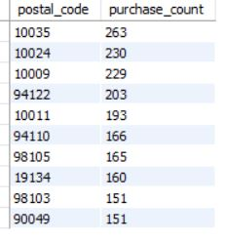

Challenge: no customer id: so postal code was used to group customers. However there may be more than one customer per post code

#8. Who are the highest spending customers overall?
# use post code for customers to group by sales

select postal_code as customer, sum(sales) as tot_spend from orders
group by customer
order by tot_spend desc
limit 10;
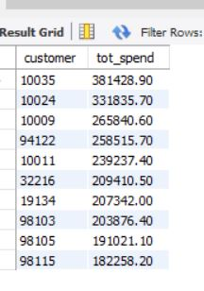
#9. What is the average number of items per order?
# order_id , avg(quantity)

select order_id , avg(quantity) as avg_num_items from orders
group by order_id
order by avg_num_items
limit 10;

SELECT AVG(items_per_order) AS avg_items_per_order
FROM (
SELECT order_id, SUM(quantity) AS items_per_order
FROM orders
GROUP BY order_id
) t;

- Which products show consistent month-over-month growth in sales?

# challenge grouping by month and product, breaks month up

# 10. How many unique customers placed orders in each month?
# month(date) , count(distinct post code), order id
select month(order_date2), monthname(order_date2), count(distinct postal_code) from orders
group by month(order_date2), monthname(order_date2);

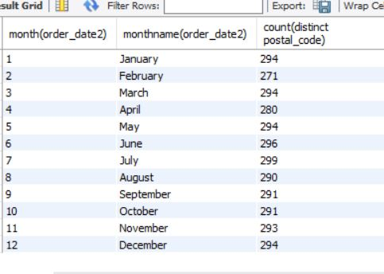

Trends & Patterns - // charts (matplotlib)
# 12. What are the peak sales periods (e.g., month or season)?

SELECT
DATE_FORMAT(order_date, '%M %Y') AS sales_month,
format(SUM(sales),2) AS total_sales
FROM orders
GROUP BY sales_month
ORDER BY total_sales DESC
LIMIT 8; -- top peak month

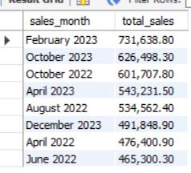

#13. Are there any seasonal patterns—like higher sales on weekends or holidays?

select dayname(order_date) as day_ , format(sum(sales),2) as tot_sales from orders
group by day_
order by tot_sales desc;

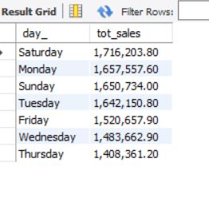

#17. What is the average and median order size?
# select avg (order_id)
# sum quantity as order size, and find average quantity

with total_order as
(select order_id, sum(quantity) as order_size from orders
group by order_id)
select avg (order_size) as avg_order_size from total_order;

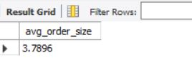

#18. What is the average number of items per order?

with total_order as(
select order_id, sum(quantity) as item_per_order from orders
group by order_id)
select avg (item_per_order) avg_order_per_item from total_order;

